**CLOUD COMPUTING SERVICES LAB (AWS)**

**WEEK 9.1:** Deployment of Machine Learning Model

**OBJECTIVE:** Design,Development and Deployment FastAPI Application on Windows EC2

**PROCEDURE:**

**Phase 1:** Build Machine Learning Model and create Pickle file (reg.pkl)

**Phase 2:** Create FastAPI Application

**Phase 3:** Create GitHub Repository

**Phase 4:** Create Windows EC2 Instance and Connect using RDP Client

**Phase 5:** Deploy FastAPI from GitHub Repository

**PHASE 1:** Build Machine Learning Model and create Pickle file (reg.pkl)

**PHASE 2:** Create FastAPI Application

1. Download and Install Python from <https://www.python.org/downloads>
2. Create FastAPIDemo Folder
3. Copy reg.pkl file into the folder
4. Go to FastAPIDemo and type code . command to open project in VS Code
5. Create app.py file
6. Installing FastAPI Library and its Dependencies in Terminal

pip install fastapi uvicorn

1. Create **index.js** file and Write “Hello World” JavaScript Code

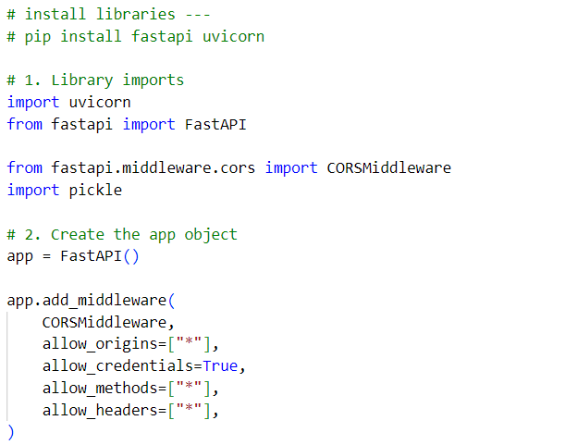

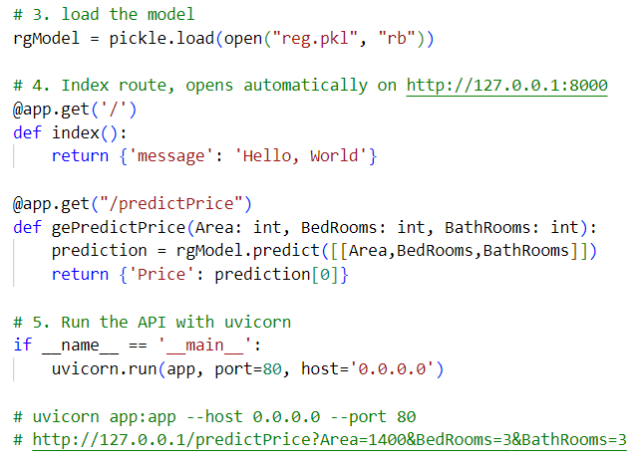

1. Run Project: uvicorn app:app --host 0.0.0.0 --port 80
2. Open Browser and Type [127.0.0.1/predictPrice?Area=1400&BedRooms=3&BathRooms=1](http://127.0.0.1/predictPrice?Area=1400&BedRooms=3&BathRooms=1)

**PHASE 3:** Create GitHub Repository

1. Create GitHub Account
2. Login to your Account
3. Create Public Repository
4. Upload Files (app.py and reg.pkl only)

**PHASE 4:** Create Windows EC2 Instance and Connect using RDP Client

**PHASE 5:** Deploy FastAPI Application from GitHub Repository

1. Connect Windows EC2 instance using RDP Client
2. Download and Install Python from <https://www.python.org/downloads>
3. Download Git Repository (.zip) from <https://github.com/Rambabu1969/FastAPIDemo> 🡪 Extract into Project Folder
4. Go to Project Folder 🡪 run pip install fastapi uvicorn – to install dependencies
5. Run uvicorn app:app --host 0.0.0.0 --port 80
6. Open Browser and type <http://127.0.0.1/predictPrice?Area=1400&BedRooms=3&BathRooms=3>
7. Open Windows Firewall and Allow port 80
8. Configure AWS EC2 Security Group to allow Port 80
9. Browse Node.js Express Application using **http://Public IP Address**